Timeline
1. Monday, May 29, 2023 – Afternoon Sessions – Present early ideas for the Objective / Concept of your Project, including a walkthrough of how it will be used. ✅
2. Tuesday, May 30, 2023 – Afternoon Sessions – Present refined (based on feedback) ideas for the Objective / Concept of your Project with more thoughts on details ✅
3. Wednesday, May 31, 2023 – Afternoon Sessions – Present your initial Circuit Design, Enclosure Design plans, and Pseudo-Code ✅
4. Thursday, June 1, 2023 – Afternoon Sessions – Present your refined Circuit Design and Enclosure Design plans (with renderings), more advanced code examples, and draft postcard.✅
5. Friday, June 2, 2023 – Afternoon Sessions – Present your nearly final designs for PCB, housing, code, postcard, renderings, and documentation ✅

6. Sunday, June 4, 2023 – Special Weekend Afternoon Session – final manufacturing files reviewed and sent to WeNext and JLCPCB

7. Friday, June 9, 2023 – 11:59 pm – Submit all final documents to Brightspace as a well-organized folder, compressed to a single ZIP file.

Design idea:


Outside temperature and its impact on the operation of AC
https://airandenergynwfl.com/blog/does-outside-temperature-affect-air-conditioner#:~:text=The%20performance%20of%20your%20air,your%20system%20to%20break%20down.

United Arab Emirates, September 2022: The price of electricity is 0.079 U.S. Dollar per kWh for households and 0.110 U.S. Dollar for businesses which includes all components of the electricity bill such as the cost of power, distribution and taxes.

This is an approximate figure and can vary depending on the size of the area and the usage. Yearly Demand Charge: 6 RT (The RT load of the A/C of your unit) * 750 = 4500 AED per Year.

Indoor temperature is the temperature you keep your home at when all the windows and doors are shut. This temperature tends to range between 10 and 15 degrees cooler or warmer than the outside, depending on the season.

https://www.luceaircon.sg/blog-article/how-to-calculate-electricity-usage-of-your-air-conditioner#:~:text=To%20get%20the%20energy%20consumption,or%201.2kWh%20per%20day.
- To calculate the power or electricity cost of your air conditioner, multiply the electricity consumption or the per kilowatt hour (kWh) by the tariff rate (e.g. 20 cents/kWh).
- To get the energy consumption (kWh), simply multiply the appliance wattage (kW or W) by the number of hours you use.
- For example, if you are using a 300W air conditioner for 4 hours per day, then you are consuming about 1200Wh or 1.2kWh per day. In one month, the consumption cost will be 1.2kWh x 30 days x 0.20 $/kWh) = $7.20.

United Arab Emirates electricity prices | Household, kWh | Business, kWh
U.A.E. Dirham | 0.290 | 0.405
U.S. Dollar | 0.079 | 0.110

https://www.globalpetrolprices.com/United-Arab-Emirates/electricity_prices/

0.07

Documentation
https://learnembeddedsystems.co.uk/m5stack-refreshes-the-m5stamp-c3-risc-v-microcontroller

ONLY ONE of the M5Stamp C3 Mate (https://docs.m5stack.com/en/core/stamp_c3) ✅
development board. You can plan on either surface-mount soldering the M5Stamp-C3 to your circuit board, or using header pins to connect it. This will depend on your application.

ONE or more of the Worldsemi WS2812C-2020-V1 LED (https://jlcpcb.com/partdetail/Worldsemi-WS2812C_2020V1/C2976072 ) ✅

ONLY ONE of either (incorporate one of these even if your initial design and application doesn’t appear to require it): ○ The TDK MPU-6500 Accelerometer and Gyroscope (https://invensense.tdk.com/products/motion-tracking/6-axis/mpu-6500/) ✅

ONE or more of the Vishay VEML7700 Light Sensor ✅ (https://www.vishay.com/en/product/84286/).

ONLY ONE of the Bosch BME280 humidity, barometric pressure and ambient temperature sensor (https://www.bosch-sensortec.com/products/environmental-sensors/humidity-sensors-bme280/ ). ✅

Light sensor
Supply voltage range VDD: 2.5 V to 3.6 V
Pinning 1: SCL 2: VDD 3: GND 4: SDA
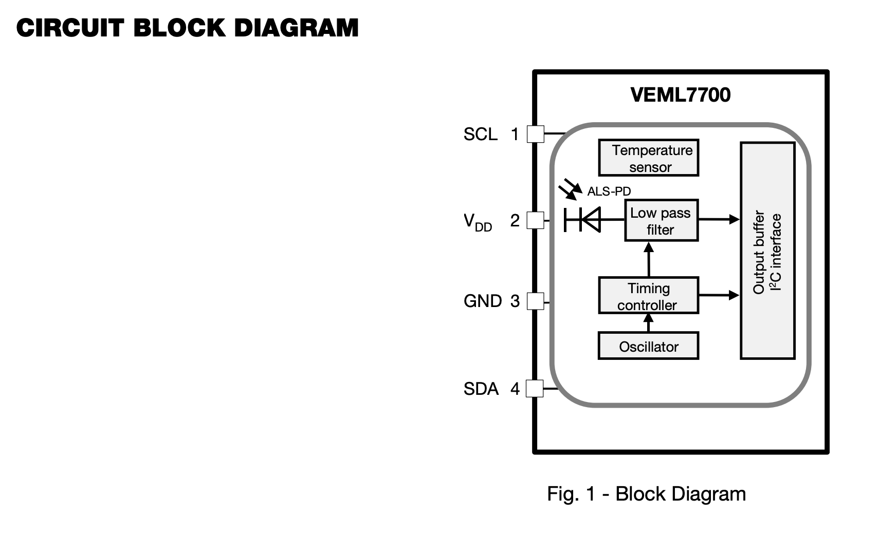

Changes: connect SDO on BME280 to GND

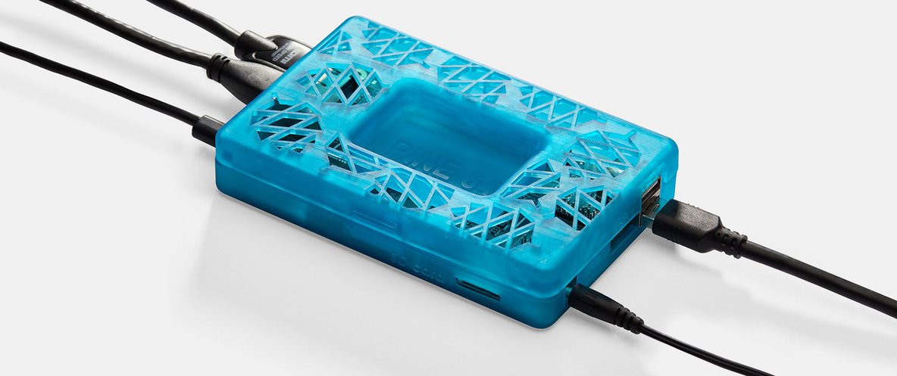



Calculating the appliances in KWH
https://www.constellation.com/energy-101/understanding-energy-costs.html#:~:text=Multiply%20kilowatts%20by%20the%20average,electric%20bill%20for%20the%20month.

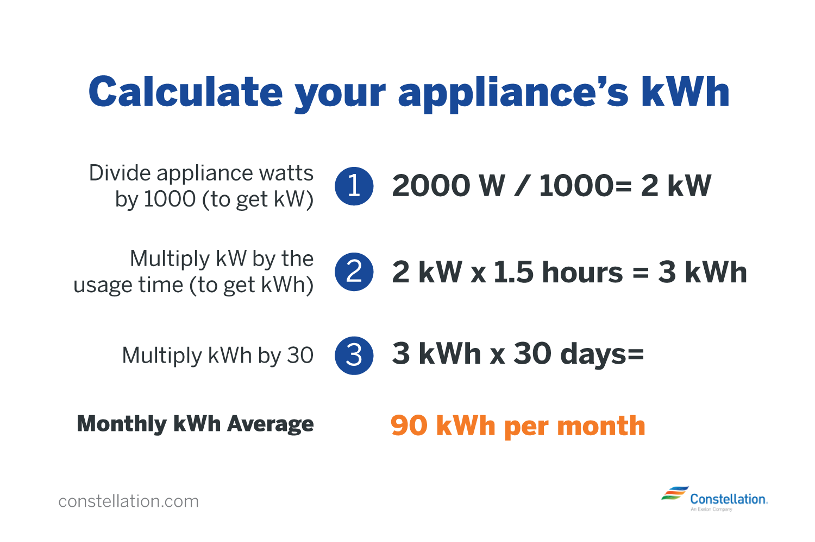

How to Calculate AC Power Consumption?
Listed below are a few important things to consider when calculating AC power consumption-
- KW rating of the AC ( it is available on the AC nameplate)
- The AC’s daily total running hours
- The total cost of 1 unit of the electricity board (let’s consider Rs. 6 as the per unit cost of the electricity)
The formula to calculate AC power consumption is-
Units per month = kW of AC * Daily running hours * 30 or 31 (month)

Dorm Room AC device is Siemens
https://www.globalpetrolprices.com/United-Arab-Emirates/electricity_prices/#:~:text=United%20Arab%20Emirates%2C%20September%202022,of%20power%2C%20distribution%20and%20taxes.
United Arab Emirates, September 2022: The price of electricity is 0.079 U.S. Dollar per kWh for households and 0.110 U.S. Dollar for businesses which includes all components of the electricity bill such as the cost of power, distribution and taxes.

United Arab Emirates electricity prices | Household, kWh | Business, kWh
U.A.E. Dirham | 0.290 | 0.405
U.S. Dollar | 0.079 | 0.110

https://www.tcl.com/in/en/blog/how-much-electricity-does-an-air-conditioner-use#:~:text=Air%20conditioner%20usage%20varies%20based,consume%20between%202900%20and%204100.

Air conditioner usage varies based on the size of your AC. However, generally speaking, a central air conditioner will consume between 3000 and 3500 watts per hour. While window units use between 900 and 1440 watts per hour, portable units consume between 2900 and 4100.

https://news.energysage.com/how-many-watts-does-a-light-bulb-use/#:~:text=Key%20takeaways%20about%20powering%20a,hours%20of%20electricity%20per%20year.
How much electricity does a light bulb use?
Generally, light bulbs use between 2 and 100 watts (W) of electricity, depending on the size and type. Traditional incandescent bulbs use 25 to 100 W, and LED bulbs use 2 to 18 W. Light bulbs draw around 110 volts and usually less than 1 amp.
How much you use your light bulb has the biggest impact on how much electricity it uses over time – on average, lights are on for about 2 hours per day in U.S. homes. Taking an average 60 W incandescent light bulb:
- Using your light bulb for 1 hour per day results in 0.42 kilowatt-hours (kWh) of electricity per week, 1.83 kWh per month, and 21.9 kWh per year.
- 2 hours per day of light bulb usage comes to 0.84 kWh per week, 3.65 kWh per month, and 43.8 kWh per year.
- On the upper end, running a light bulb for 3 hours per day uses 1.26 kWh of electricity per week, 5.48 kWh per month, and 65.7 kWh per year.
With a more energy efficiency LED light bulb (averaging 10 W), here’s what your energy usage could look like:
- Using an LED light bulb for 1 hour per day results in 0.07 kilowatt-hours (kWh) of electricity per week, 0.30 kWh per month, and 3.65 kWh per year.
- 2 hours per day of LED light bulb usage comes to 0.14 kWh per week, 0.61 kWh per month, and 7.30 kWh per year.
- On the upper end, running an LED bulb for 3 hours per day uses 0.21 kWh of electricity per week, 0.92 kWh per month, and 11.0 kWh per year.

VEML7700 - lux units

https://www.aircomfort.com/how-high-humidity-affects-your-central-air-conditioning-system-and-what-you-can-do-about-it/#:~:text=High%20humidity%20cancels%20out%20the,not%20getting%20the%20desired%20effects.
Relationships between humidity and AC:
High humidity cancels out the air conditioner’s cooling effect. When the humidity is too high, your building will feel warmer than it is. You may find yourself running the air conditioner harder for longer and not getting the desired effects. You’ll know that the humidity in your building is too high if:
- The air in your building feels moist.
- There is a damp or musty smell in parts of your building.
- Your windows are foggy.
High humidity outdoors and in your building can both negatively affect the cooling potential of your HVAC system. HVAC experts recommend a humidity level below 60% for your building to be comfortable

https://www.lg.com/ae/air-conditioning/ideal-temperature-settings-for-your-ac

Ideal temperatures for different occasions
Ideal room temperature during summer
During the summer, the ideal room temperature is between 22 and 26 degrees Celsius. This temperature range is considered comfortable for most people during the summer months, as it helps keep the room cool while providing a comfortable living environment. An ideal temperature range may vary depending on factors such as the room's location, the amount of sunlight it receives, and the insulation of the walls and windows.
Ideal room temperature during winter
During the winter, the ideal room temperature is typically between 18 and 20 degrees Celsius. While it may seem logical to increase the temperature indoors during winter to combat the colder temperatures outdoors, this is not advisable for health reasons. A significant temperature difference between indoors and outdoors can affect your body’s ability to adapt and negatively affect your immune system, leaving you more vulnerable to winter colds and other illnesses. Keeping your home’s temperature between 18 and 20 degrees Celsius helps keep the room warm while providing a comfortable living environment.
The ideal temperature for sleep during the winter is slightly lower than during the day. A cooler room temperature at night (between 16 and 18 degrees Celsius) can help to regulate the body's internal temperature during sleep.

